

**Design and Analysis of Iot**

**(SOFE 4610U)**

**Project Deliverables: Architectural Design Decisions**

Dr. Ramiro Liscano

Fall 2021

12/06/2021

Zainab Rehan - 100653955

Ramin Sami - 100655257

Jane Coralde - 100660214

Amin Khakpour - 100669547

# Architectural Design Decisions

Not many architectural decisions were made by the group due to the fact that we were following the textbook Build Your Own IoT Platform, as such, we would reference applied architectural implementation as per textbook and compare with other applications.

Image grabbed from textbook, captioned as block diagram of typical IoT platform

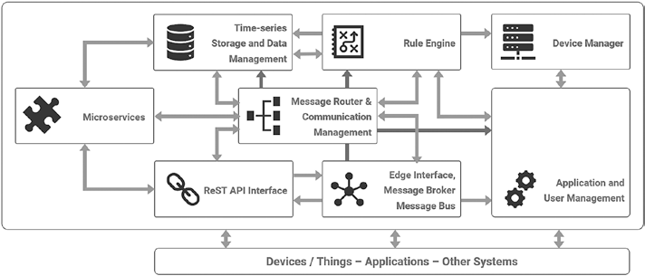

As per textbook, essential components were only applied and as a result, block diagram is updated below

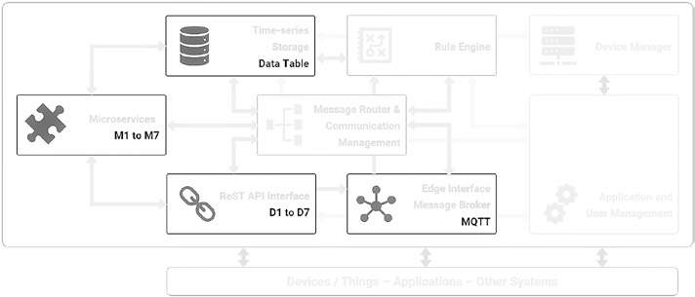

The design decisions that were made by the group are listed below.

Level Specification

Our project falls under the category of a level-2 IoT system. This means that we have a single sensor and device which does the sensing. The data itself is stored in a cloud-based database and the application is hosted via the cloud.

We chose a level-2 IoT system because our device is relatively low-cost and low-complexity. The data which we store and analyze is not too big and the analysis requirements are not computationally intensive and can be done locally before being stored in the cloud.

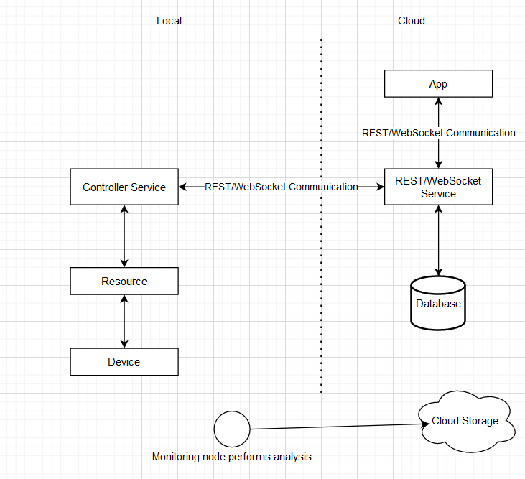

Functional View Specification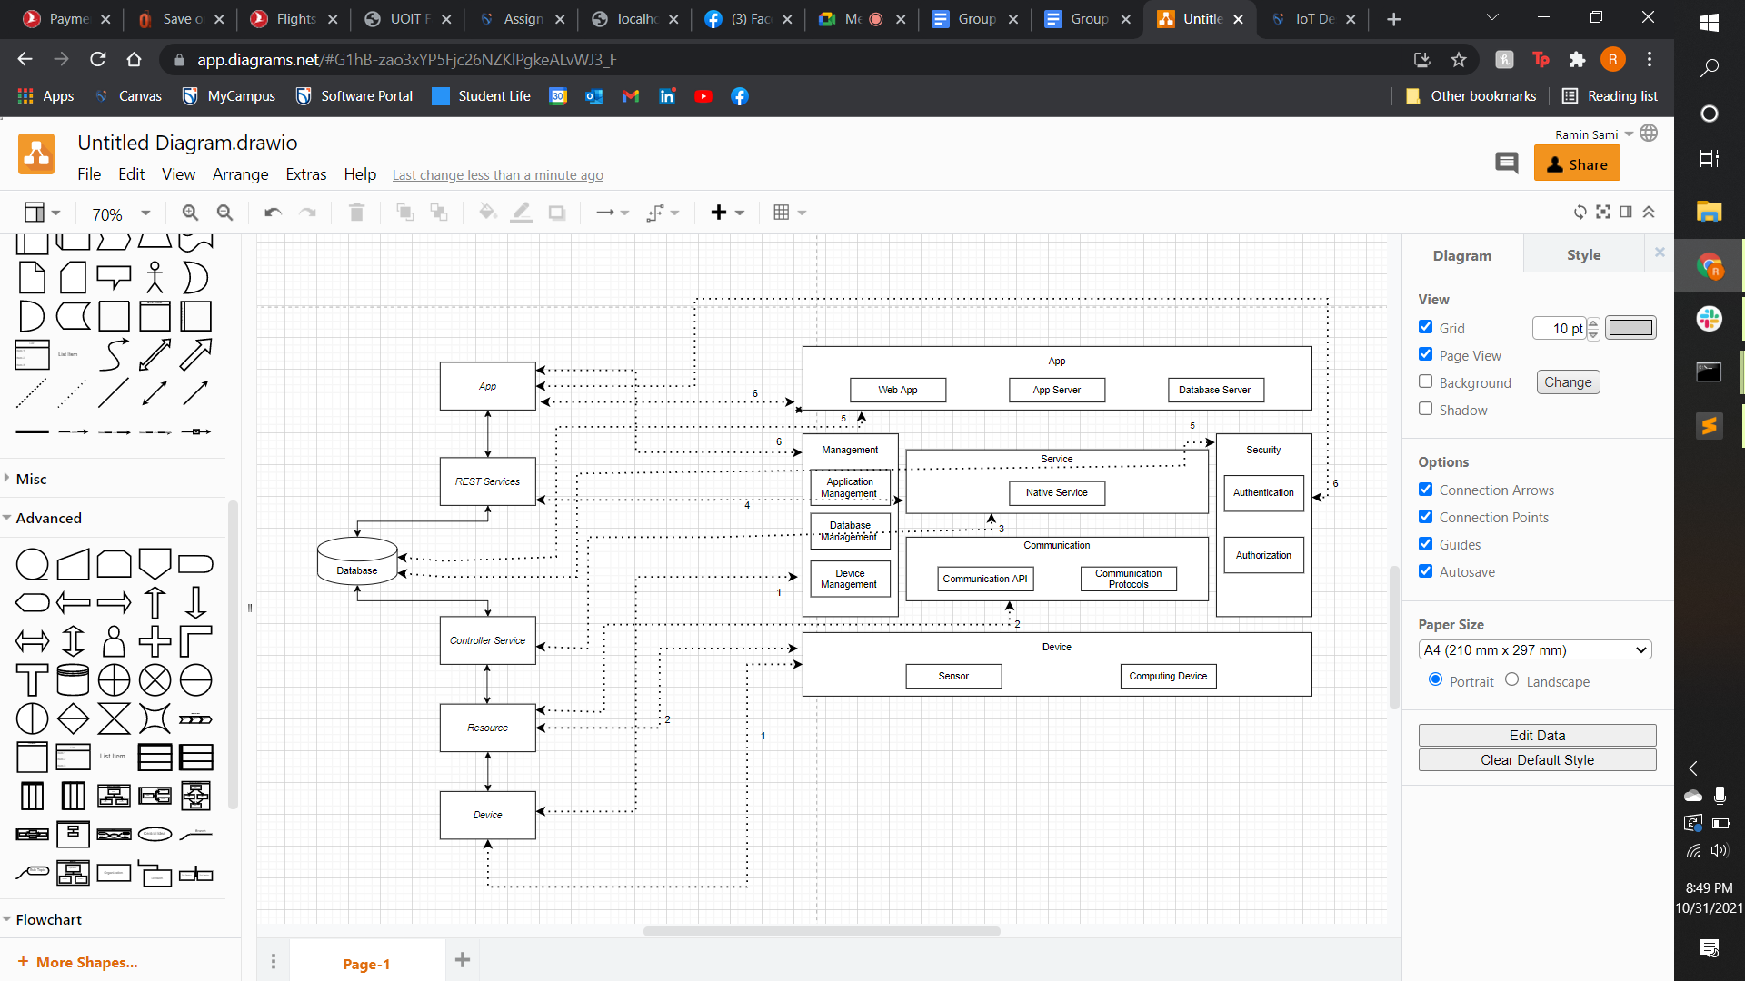

**Steps**

1. IoT device maps to the Device (sensor and computing device) and the Management (device management)
2. Resources map to the Device and the Communication (communication APIs and protocol)
3. Controller service maps to the Services.
4. Database maps to the Services(Database Management) and Security(Database Security)
5. Application maps to the Applications(Web App, App Server, and Database Server), Management (App Management) and Security(App Security)

Design Decisions

Components:

* **Ultrasonic Sensor:** Measures distance using ultrasonic sound waves by using a transducer to send and receive electronic pulses. It is used in our project to determine how filled a trash can is.
* **Node MCU:** Base controller which is connected to an online broker. It temporarily stores values from the ultrasonic sensor before publishing it to the broker. Node MCU was chosen as the base controller because we had some prior experience using it and because there were a lot of resources for it available online.
* **MQTT Broker:** Where the data from the Node MCU is published to and stored in. We shoce to use an MQTT broker because two of our assignments and some of the labs utilized it. Therefore we were more comfortable using it for our project than we were any other broker.
* **Django Application:** Application which user interacts with in order to see the data collected from the device. A Django application was chosen because one of our group mates had experience working with it before and since we were suing the Python language to code, the Django framework seemed like a good choice for the project